

Microsoft Cloud for Sustainability in a Day

Environment Setup

Step-by-Step

Overview

**Background**

In this lab for Microsoft Cloud for Sustainability you will create your training environment.

**Learning Objectives**

In this lab, you will perform the following:

* Set up a new trial tenant.
* Set up a new Microsoft Cloud for Sustainability trial instance.

Exercise 1: Setup Microsoft Cloud for Sustainability Trial

In this exercise, you will learn about the steps that are required to set up a new trial for Microsoft Cloud for Sustainability in a new tenant.

* We suggest using In-private browsing, or a new browser profile.

**Task 1: Create a Microsoft 365 tenant**

In this task, you'll learn how to create a trial tenant along with the required Microsoft Dynamics 365 and Microsoft 365 trial licenses. You can skip this task if you already have a tenant.

1. Open an internet browser in In-Private or Incognito mode.
2. Go to [https://trials.dynamics.com](https://trials.dynamics.com/), scroll down, and then select **Try for free** in the **Dynamics 365 Customer Service** card.

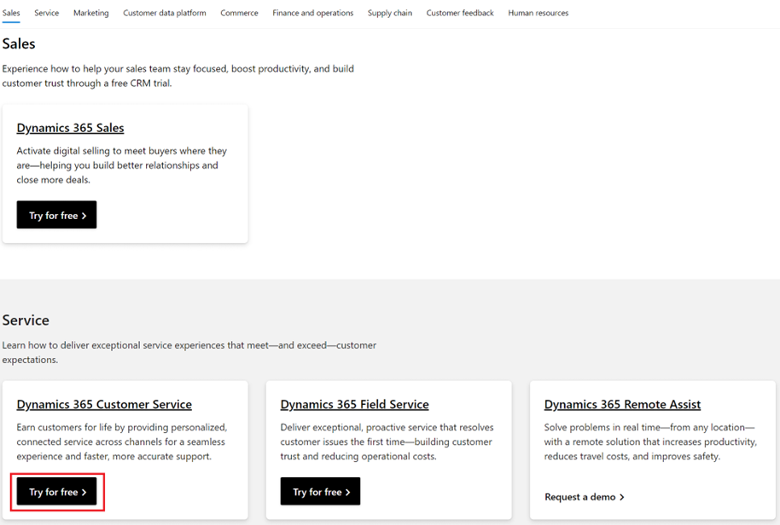

1. A pop-up window will appear, asking you to enter your email to start your free trial. Click the link to create new Azure active directory trail account .

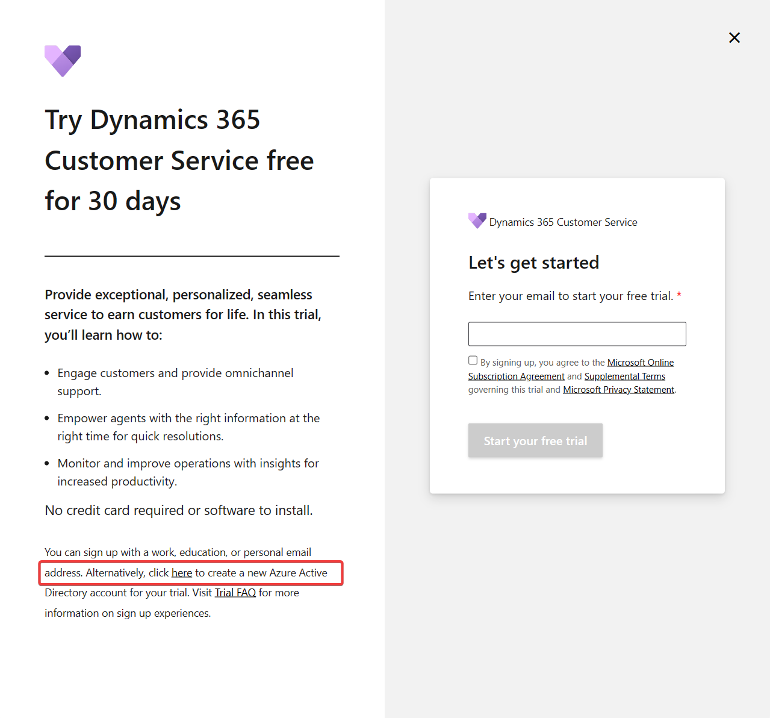

1. A new account creation flow for Dynamics 365 Customer Service Enterprise Admin Trial will display. Get started by entering your email address in the format <YourUserName>@ <YourUniqueTenantName>.onmicrosoft.com.

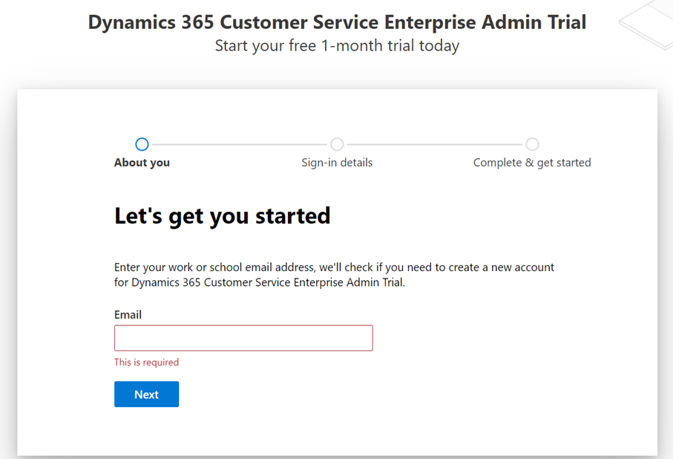

1. If the email is already using other Microsoft services, the following warning will appear. Select **Create a new account instead**

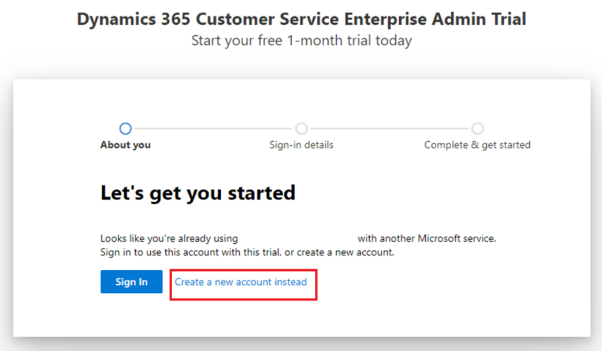

Else, it will prompt you to set up your new account. Select **Set up account**.

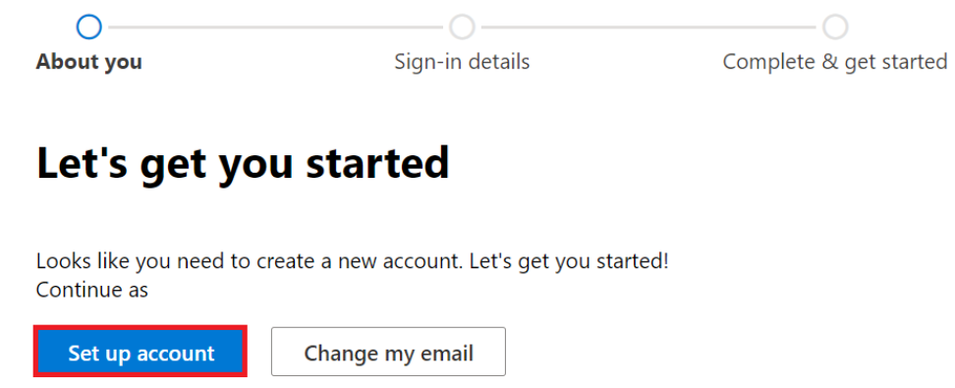

1. Provide the necessary information in the About you page. Enter a valid phone number where you can receive a text message to validate the sign-up process.

1. After the verification has completed, you can request a valid domain name, and then select **Save** to check availability. If an error doesn't appear, the domain is ready to be used.

1. Set up a username and password and then sign in.

1. Enter your Company’s TIN (Taxpayer Identification Number) if the following page appears.

**Congratulations!** Your Microsoft 365 tenant has been successfully created along with the Dynamics 365 Customer Service license that includes a Microsoft Power Apps license as well.

**Task 2: Obtain a Microsoft Office E5 trial**

In this task, you'll add the necessary Office 365 trial to use One Drive for data ingestion in Cloud for Sustainability.

1. With your newly created credentials in the previous task, go to [Microsoft 365 admin center](https://admin.microsoft.com/).
2. Go to **Billing > Billing accounts** and select the **Billing account** record.

1. Select **Edit** to edit the billing account details and provide a valid address and phone number. This step is important for the address validations kick-off. Select **Save**.

1. Now, go to **Billing > Purchase Services**, select **Office 365**, scroll down to **Office 365 E5**, and then select **Details**.

1. Select **Start free trial**.

1. Enter a valid phone number to prove that you're not a robot and go through the verification process.

1. Select **Try now** to start your free trial.

1. Select **Continue** to return to the admin center.

1. Assign the newly acquired Office 365 E5 trial license to a user by going to **Users > Active users**. Select a user and then select **Manage product licenses**.

1. Select the **Office 365 E5** license and then select **Save changes**.

**Task 3: Obtain a Microsoft Cloud for Sustainability trial**

In this task, you'll request a Microsoft Cloud for Sustainability trial environment to be added to your tenant.

1. With your newly created credentials in the task 1, go to [Free Trial | Microsoft Sustainability Manager](https://dynamics.microsoft.com/en-us/sustainability/sustainability/free-trial/), enter your newly created account in the email address box, and click “Start your free trial”

1. Enter your phone number and click Submit

2. A new trial instance of Microsoft Cloud for Sustainability has been created for you.

**Congratulations!** By completing these steps, you have created a new trial instance of Microsoft Cloud for Sustainability. You can continue with the remaining labs.